SOCIAL MEDIA READY RESOURCES

**HOW TO STAY RESILIENT DURING COVID CRISIS**

*Please use the text and images to form your social media post which can link to our Ethos Blog for more resources. You have permission to use and amend this text and image for your school context*

*COPY & PASTE – SCHEDULE ALL THREE FOR MAXIMUM IMPACT ACROSS THE WEEK*

**POST OPTIONS**

Post 1:

Why is resilience such a great super power? In a time filled with so much uncertainty, learning how to be resilient is essential. Read the latest ETHOS blog post to learn more about what resilience is and how to practice it during the COVID Crisis.

<https://www.grace-foundation.org.uk/resilience>

Post 2:

However you are feeling right now about the future, having a resilient mindset is vital to help you and your family make it through. Check out the latest ETHOS blog to discover simple things you can do each day to stay resilient during this pandemic.

<https://www.grace-foundation.org.uk/resilience>

Post 3:

Need to know how to stay resilient during the Covid Crisis? Us too! How about we learn how to #beresilient together? Let’s get ourselves ready for action so we can go and support others.

<https://www.grace-foundation.org.uk/resilience>

**IMAGE OPTIONS ON NEXT PAGE**

**HIGH RES VERSIONS:**

**12 Second Video to use:** [**https://www.grace-foundation.org.uk/wp-content/uploads/2020/05/Resilient-Video.mp4**](https://www.grace-foundation.org.uk/wp-content/uploads/2020/05/Resilient-Video.mp4)

**Quote Image to use:**

[**https://www.grace-foundation.org.uk/wp-content/uploads/2020/05/Monochrome-Photo-Fall-Quote-Instagram-Post-3.png**](https://www.grace-foundation.org.uk/wp-content/uploads/2020/05/Monochrome-Photo-Fall-Quote-Instagram-Post-3.png)

**Header Image:**

[**https://www.grace-foundation.org.uk/wp-content/uploads/2020/05/Black-and-Green-Soccer-Blog-Header-1-e1590156391109.png**](https://www.grace-foundation.org.uk/wp-content/uploads/2020/05/Black-and-Green-Soccer-Blog-Header-1-e1590156391109.png)

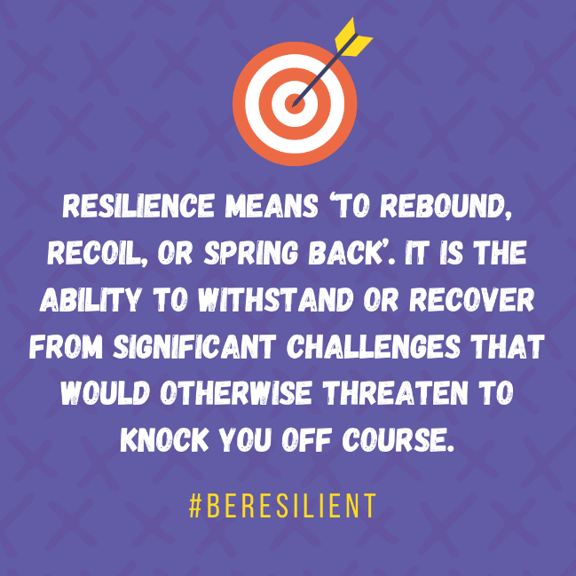

Below is a screen shot from the video link (found on page 1)

