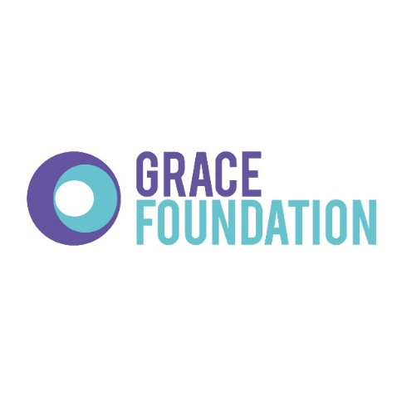

Uncontrolled once printed

1

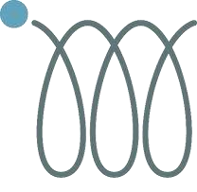

Capability

Policy



**Document Owner:**

Human Resources

**Approved By:**

Sonia Hall

**Date Approved:**

01/05/2021

**Version:**

6

**Security Classification:**

Internal use only.

**Version**

**Revision Date**

**Revised by**

**Section Revised**

**4**

08

18

/

HR Manager

Whole

document

**5**

/

08

19

HR Manager

None

**6**

0

5

/21

HR Manager

Reformatted

Contents

1. Introduction 3

2. Purpose 3

3. Policy 3

4. Informal Capability Procedure 3

5. Formal Capability Procedure 4

6. Formal Sanctions 5

Stage 1: Written improvement notice 5

Stage 2: Final written improvement notice 5

Stage 3: Dismissal 6

Appeals 6

7. Short Service Staff 6

# Introduction

This document provides a fair and consistent process for supporting employees where capability has become a cause for concern.

This capability procedure is entirely non-contractual and does not form part of an employee’s contract of employment.

Throughout this policy, references to “the Company” mean I.M. Group Limited and/or your employer within the group of companies headed by I.M. Group Limited as appropriate. This includes Grace Foundation.

# Purpose

The policy and procedure provides a framework within which the Company can enable employees to maintain satisfactory performance standards and to manage improved performance and attendance, where necessary.

# Policy

The Company recognises the difference between a deliberate or reckless failure on the part of an employee to perform to the required standards, and where an employee lacks the skills, knowledge and capability to do their job. Where deliberate or harmful underperformance is identified, this will be dealt with under the Disciplinary policy. This policy is to be used when, despite efforts from the employee and their line manager, the performance is not at the required standard.

Performance may also be affected by personal/family circumstances or ill health, which is also covered in this policy. The Company aims to provide a supportive and practical environment in which the employee and manager can work together to increase levels of performance as a result of ill health. Ill health or challenging personal circumstances may also prevent an employee from attending work or performing to the best of the abilities. These situations are also covered in the Sickness Absence policy.

At all capability management stages, the Company will give consideration to whether the unsatisfactory performance/attendance is related to a disability and, if so, whether there are any reasonable adjustments that could be made to the employee’s job or other aspects of the working environment.

# Informal Capability Procedure

Minor capability issues will often be resolved via timely feedback, counselling and training. Informal discussions may be held with a view to clarifying the required standards of performance or attendance, which is the responsibility of the line manager.

If performance does not improve as a result of an informal discussion, the employee must be advised of the areas of concerns and where the improvement needs to be made in an informal capability meeting. The informal meeting should also explore the likely causes of poor performance, identify any training or supervision needs, set targets for improvement and set a performance improvement period. The line manager may decide to use the Performance Improvement Plan as part of this improvement period (please see HR Department for this template).

The improvement period is a set period of time which allows the employee to demonstrate increase capability/performance/outputs. It should be long enough to allow the required tasks and responsibilities to start and finish, so an accurate and fair measure of performance can be taken. This improvement period would normally last 3 – 6 weeks. Please see HR for further information. At the end of the agreed improvement period, a review meeting is called to assess the performance against agreed objectives.

However, in cases where informal discussion with the employee does not lead to a satisfactory improvement, or where the performance/attendance issues are more serious, the following formal capability procedure will be used.

# Formal Capability Procedure

The Company will notify the employee in writing of the concerns over performance/attendance and will invite the employee to a formal capability review meeting to discuss the matter. The Company will provide sufficient information about the poor performance/attendance and its possible consequences to enable the employee to prepare to answer the case. This will include the provision of copies of written evidence where appropriate.

Having given the employee reasonable notice of the formal capability review meeting (normally 3 working days), the meeting will take place, conducted by a line manager and an HR representative. The employee will be offered the opportunity to be accompanied by either an accredited trade union official or a colleague of their choice. The employee must make every effort to attend the meeting.

The purpose of the capability review meeting is:

* to set out the required standards that the Company considers the employee has not met,
* to establish the likely causes of poor performance/attendance (including any reasons why any measures taken so far have not led to the required improvement)
* to allow the employee the opportunity to explain the poor performance/attendance and to ask any relevant questions.
* to discuss practical support and measures, such as additional training or supervision, which may improve the employee’s performance/attendance,
* to set targets for improvement and to set a formal improvement period which allows the employee to demonstrate increased capability/performance/outputs.

Following the formal capability review meeting, the Company will decide whether or not formal sanction is justified and, if so, the employee will be informed in writing of the Company’s decision. Please see more information in section 6 of this policy.

At the end of the agreed formal improvement period, a review meeting is called to assess the performance against agreed objectives. Should the employee have made the required improvements and can demonstrate that they can meet the expected level of performance/attendance, no further capability meetings will be required.

If an employee’s performance/attendance worsens within a reasonable period of time after the formal capability meeting, the employee shall return to the formal capability procedure.

If an employee’s performance and outputs do not meet the standards set out in the formal improvement period, a second stage formal capability review shall be called. All steps detailed in section 5 shall be repeated in the second stage formal capability review.

Following the second stage formal capability review meeting, the Company will decide whether or not a formal sanction is justified and, if so, the employee will be informed in writing of the Company’s decision. Please see more information in section 6 of this policy.

If an employee’s performance and outputs do not meet the standards set out in the formal improvement period, a final stage formal capability review meeting shall be arranged. All training, support, reasonable adjustments, performance measures and employee comments shall be reviewed at this meeting to ascertain why the employee is consistently underperforming. If no reasonable explanation can be offered, the employee may face dismissal, as detailed in section 6 below.

# Formal Sanctions

## Stage 1: Written improvement notice

At the first stage formal capability review meeting, the employee is likely to be given a formal improvement notice. This notice will set out the areas in which the employee has not met required performance/attendance standards, targets for improvement and any measures (such as additional training or supervision) which will be taken to improve the employee’s performance/attendance.

The written improvement notice will be kept on the employee’s personnel file but nullified after six months, subject to satisfactory performance/attendance levels.

The employee’s performance/attendance will be monitored during the review period If the employee has achieved the required level of performance/attendance, no further action will be taken. If the employee has not achieved the required level, the matter may be progressed on to Stage 2, or if the Company feels that there has been substantial but insufficient improvement, the review period may be extended.

## Stage 2: Final written improvement notice

A final written improvement notice may be given in the following circumstances:

* Failure to improve performance/attendance during the first stage improvement period
* During the time a written notice period is still ‘live’
* In the first instance of serious poor performance

This notice will set out the areas in which the employee has still not met the required performance/attendance standards, targets for improvement and any further measures (such as additional training or supervision) which will be taken with a view to improving the employee’s performance/attendance.

The final written improvement notice will be kept on the employee’s personnel file but nullified after twelve months, subject to satisfactory performance/attendance levels.

The employee’s performance/attendance will be monitored during the review period If the employee has achieved the required level of performance/attendance, no further action will be taken. If the employee has not achieved the required level, the matter may be progressed on to Stage 3, or if the Company feels that there has been substantial but insufficient improvement, the review period may be extended.

## Stage 3: Dismissal

Failure to improve performance/attendance in response to the procedure so far will normally lead to dismissal, with appropriate notice. The Company may first consider redeploying the employee with their agreement to another available job at the same or lower grade which is more suited to their abilities. A dismissal decision will only be made after the fullest possible investigation, including full consideration of any health conditions or disabilities that could affect performance/attendance. Dismissal can be authorised only by a senior manager. The employee will be informed of the reasons for dismissal, the appropriate period of notice, the date on which their employment will terminate and how the employee can appeal against the dismissal decision.

## Appeals

An employee may appeal against any formal sanction under this capability procedure, including dismissal, to a senior manager or Director of the Company within five working days of the decision. Appeals should be made in writing and state the grounds for appeal. The employee will be invited to attend an appeal meeting chaired by a senior manager or a Director.

At the appeal meeting, the employee will again be given the chance to state their case and will have the right to be accompanied by a trade union official or a fellow employee of their choice.

Following the meeting, the employee will be informed in writing of the appeal decision. The Company’s decision on an appeal will be final.

# Short Service Staff

We retain discretion in respect of the capability procedures to take account of your length of service and to vary the procedures accordingly. If you have a short amount of service, you may not be in receipt of any warnings before dismissal.