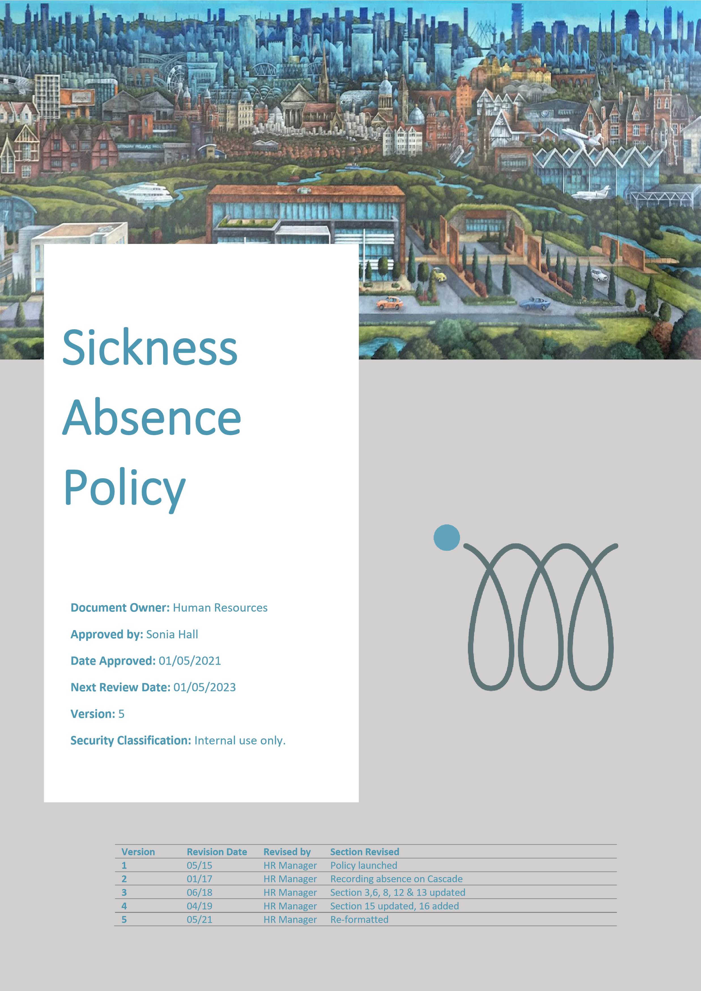

**Contents**

1. Introduction 3

2. Policy Overview 3

3. Reporting Absence 3

4. Contact during Absence 4

5. Certificating Absence 4

6. Return to work and recording absence 5

7. Returning to work after long term sickness (3 weeks continuous absence or more) 5

8. Return to Work Interview 6

9. Sickness absence following an accident at work 7

10. Sickness following an accident whilst not at work 7

11. Working from home whilst sick 7

12. Taking holiday when sick 7

13. Managing absence and Bradford Factor 8

14. Absence management procedure 8

14.1 Stage 1 – Informal absence management meeting 8

14.2 Stage 2 – Formal absence review meeting 9

14.3 Stage 3 – Formal absence review meeting 9

14.4 Stage 4 - Final formal absence review meeting 10

15. Medical and healthcare appointments 10

16. Company Sick Pay 10

17. Statutory Sick Pay 11

# Introduction

IM Group Ltd wishes to create and support a healthy and efficient working environment which supports the employee through times of physical or mental ill health as well as supporting the achievement of business objectives by actively encouraging high levels of attendance. Illness resulting in absence from work, not only has a significant effect on the employee, but also has a major impact on the operating capability of the Company. It is envisaged that this document will assist employees to fulfil their potential and contribute to the success of the Company and advise line managers on best practice when supporting absence.

This policy is entirely non-contractual and does not form part of an employee’s contract of employment.

Throughout this policy, references to “the Company” mean IM Group Ltd and/or your employer within the group of companies headed by IM Group Ltd as appropriate. This includes Grace Foundation.

# Policy Overview

The Company seeks to ensure that appropriate arrangements are in place to minimise the likelihood of sickness absence occurring, limit the consequences for staff and the Company’s activities when sickness absence does occur, and support employees through periods of ill health with the aim of securing their return to work.

Heads of Departments and line managers have a central role in the effective management of sickness absence and its impact upon work performance and service levels. It is important all Heads of Department and line managers, supported by the Company, acquire the level of skills and training needed to conduct relevant processes in a competent and caring manner. Managers are also accountable for ensuring their employees record their sickness absence accurately on the HR system, and for making sure Return to Work interviews take place.

In applying the capability/sickness absence procedure, decisions will be made by HR and line managers based on information acquired via return to work discussions, absence review meetings, absence data and medical advice.

The arrangements set out in this document relate to sickness absence affecting the ability of members of staff to carry out their duties. Unauthorised absence is an issue of conduct that may fall within the scope of the Company’s disciplinary procedures.

The following principles govern this policy and procedure:

* **Fairness**: actions should be reasonable, necessary, known and understood. Members of staff involved are also entitled to be heard with courtesy and respect.
* **Confidentiality**: information relating to sickness absence should not be divulged to a third part not involved in the process. Any meetings or conversations around sickness absence will be undertaken in a private setting.
* **Equality**: The Company will endeavour not to discriminate unfairly or illegally, directly or indirectly.

# Reporting Absence

On the first day of absence an employee is required to telephone their line manager personally at the earliest opportunity, before the commencement of their usual start time. Texts and emails advising of absence are discouraged unless in extraordinary circumstances e.g. the employee is unable to speak, or the line manager has specifically requested the employee email or text. This employee will be required to provide the following information when reporting absence:

* the reason for the absence;
* the likely duration of the absence (if known);
* confirmation of the communication arrangements during the period of absence (if longer than a week);
* the date that the employee became sick/incapable of work, and; - whether the absence is the result of an injury sustained at work.

If the line manager is not available, then the employee must speak to a member of the HR team.

It is acknowledged that there may be very exceptional circumstances where an employee is unable to comply with the absence reporting procedure due to a sudden, critical illness. In such circumstance absence should be reported to the line manager as soon as possible via a partner or close relative.

If an employee has arrived at work and is unable to remain at work due to sickness, the employee should inform their line manager before leaving work.

# Contact during Absence

An employee must contact their line manager whenever their absence goes beyond the last reported expected duration of absence e.g. if the employee stated their absence would last for one day, they would need to contact their line manager on day two of their sickness absence.

If the employee remains sick on the third consecutive day of absence, they must again contact their line manager personally on day three before the usual start time.

The employee must update their manager every two days if the sickness absence continues up to seven consecutive days (excluding days not scheduled to work, weekends, rota days off and/or bank holidays).

If the employee is issued with a Fit Note by their GP, once they have advised their line manager of the duration of their absence and sent the Fit Note to their line manager/HR, there is no need to call in every 2 days.

The line manager is also responsible for maintaining reasonable contact during the period of absence, depending on the duration of absence. This contact may be via telephone, email or text and should be agreed between the employee and line manager. Where an employee prefers not to have regular contact with their line manager this should be referred by the employee in writing to the HR department who will endeavour to arrange alternative, acceptable and mutually agreeable contact arrangements.

# Certificating Absence

For absences of **no more than seven consecutive calendar days** (including non-working days, weekends and bank holidays), the employee is required to enter their absence onto HR system as soon as they return to work.

The return to work interview that is generated by the HR system serves to certify that period of absence. The line manager is responsible for carrying out the return to work interview as soon as possible after the employee’s return to work.

Any employee who is absent for **seven or more consecutive calendar days** (including non-working days, weekends and bank holidays), will be required to submit a Fit Note or medical certificate with effect from the 7th day of sickness and during any continuing period of absence.

The employee must forward the Fit Note/medical certificate to the HR department and should ensure that HR received the medical certificate immediately following the expiry of any previously supplied medical certificates. The employee should continue to send medical certificates to the HR department until they are medically fit to return to work.

If an employee does not provide a self-certification/medical certificate as outlined above, this will result in Company Sick Pay, if any, being withheld. Reasonable endeavours will be taken to ensure that a letter is sent out to the employee in advance of this action being taken however, on occasion this may not be possible. In this situation, the employee will be recorded as being on unauthorised absence and the circumstances investigated. If appropriate the matter made be investigated in accordance with the Company’s disciplinary procedure.

The medical certificate must be from a GP, or from the hospital at which the employee is receiving treatment.

# Return to work and recording absence

If the employee has been signed off sick, the employee must contact their line manager to confirm the date of their return to work.

If an employee is absent from work and is covered by a Fit Note/medical certificate but wishes to return to work before the expiry of the medical certificate, the line manager must advise the employee in writing that they are able to return to work, but they have not been asked to return by the Company – it is the employee that wishes to return, and they take full responsibility for any health and wellbeing consequences.

When an employee is fit to return to work, they should log their absence on HR system as soon as they return under the ‘Absence’ screen.

# Returning to work after long term sickness (3 weeks continuous absence or more)

Depending on the reasons behind the sickness absence, and any information obtained from the employee’s GP and/or Occupational Health, the following actions can be taken: **Return to work on full duties** – No changes required to role

Or

**Return to work** **with temporary/permanent changes made to role:**

On the first day back at work, the employee should report to their line manager who will conduct a return to work interview as outlined in Section 8.

If the employee has been referred to Occupational Health during this period of sickness absence, the consultant may have advised that temporary arrangements are made in order to assist the employee’s return to work. These will have previously been discussed with the individual as part of the keeping in contact arrangements during their sickness absence and should be confirmed at the return to work interview.

Any temporary arrangements will normally be implemented following recommendations from Occupational Health or from HR Team and may include:

* phased hours – working fewer hours that those contracted initially, increasing these as appropriate;
* adjusted duties – working on less physically/mentally demanding duties of the role over a recommended period of time, or;
* reduced responsibility – working at a level of less responsibility than the grade of the role

Temporary arrangements are meant to be of a short duration, usually no longer than 4 weeks. The purpose is to simply facilitate the return to work at the required level as quickly as possible and according to the medical advice.

Any temporary arrangements will be monitored through regular review meetings between the line manager and the employee to assess progress and facilitate a return to full duties, as appropriate.

In order to facilitate a smooth return to full duties, a phased return to work may be arranged that involves shorter hours/days or reduced duties or responsibilities. Where phased return to work arrangements are in place, the employee will receive their normal salary for a period of up to 4 weeks. If the temporary arrangements continue beyond 4 weeks, the salary for the employee will be adjusted accordingly to the actual hours being worked or the level of responsibility being undertaken.

If progress is less than satisfactory during the phased return to work, advice will be sought from the Occupational Health Consultant. This will be arranged by HR in consultation with the employee and line manager. The intention of such referral would be to obtain further information regarding the likelihood of the employees return to full duties, accompanying timescales and any further reasonable modifications that could be made by the Company to facilitate this process.

An Occupational Health Consultant may advise that permanent redeployment is an option. Permanent redeployment will depend on current vacancies, but priority will be given to employees who are defined as disabled under Equality Act 2010.

# Return to Work Interview

The return to work discussion is crucial in managing attendance. It is considered best practice and is an opportunity to understand reasons for absence, and to offer support in overcoming any issues or challenges in return to work.

A return to work interview will take place for any period of sickness absence of one day or more. Managers must conduct the Return to Work interview face to face with every returning employee as soon as possible on the day of their return. Where the manager is absent from work, or is off site, the return to work interview can be conducted over the phone or delegated to another line manager.

As soon as absence has an end date in the HR system, a Return to Work task will be triggered and the line manager will be prompted to complete the task.

The interview must be carried out in private, maintaining confidentiality and prompting an atmosphere of trust and to ensure consistency and uniformity of approach. The information disclosed during this meeting is held privately and confidentially on the HR system. People who have access to the Return to Work interview data are the employee, their line manager and the HR team.

As well as the questions stated on the Return to Work form, the interview may also include:

* a welcome back to work;
* a practical integration back into the workplace;
* the nature and extent of the absence;
* any work-related issues that may be related to this sickness absence;
* an update on the employee’s work and how it has been dealt with during absence;
* identification of any support mechanisms that would maintain a sustained return;
* dependent upon the nature of the absence, an introductory conversation around Occupational Health issues, counselling and health checks

During the discussion, the line manager and employee will complete the return to work form on the HR system.

# Sickness absence following an accident at work

An employee should inform their line manager where absence is a result of an accident at work. The individual must complete an accident report form so that the accident is properly recorded, and so that further incidents can be avoided. Failure to do this may impact on future sickness absence benefits. This type of absence would not normally count towards the Bradford Factor score. Employees must however ensure they have followed the correct procedure for reporting and recording accidents (please see Health and Safety Manual for more details).

# Sickness following an accident whilst not at work

If an absence is the result of an accident whilst not at work, there may still be an entitlement to Company Sick Pay, but it is required that this Company Sick Pay is refunded should damages be received from a third party.

# Working from home whilst sick

Working from home whilst sick should only be granted in exceptional circumstances and required prior agreement before it is granted. Two examples of where working from home could be appropriate are:

* Where an injury/break to a limb prevents driving to work, but the person is not in pain and can work at a laptop.
* An employee experiences an allergic reaction, causing swelling or temporary facial abnormality. They are not in pain, can work at a laptop, but would rather stay at home until the swelling has gone down.

The manager is required to have a thorough discussion with the employee to understand the reasons why they want to work from home and their suitability to do so. The Company has a legal duty of care to protect the health and wellbeing of all staff and working from home whilst sick may compromise this if not fully explored and agreed.

# Taking holiday when sick

Employees are not permitted to take holiday instead of sickness absence under any circumstances. In order to ensure sickness absence is managed and calculated fairly and accurately, the correct reason for absence must be logged on the HR system.

Line managers are also required to ensure that they take sufficient detail around the reason for absence when their employee calls in. Line managers are required to check that the correct absence reason has been logged on the HR system by the employee before they approve such absence. As soon as an employee advises their manager that they are unable to attend work due to mental or physical incapacity, the reason for the absence can only be sickness absence.

# Managing absence and Bradford Factor

An attendance threshold has been introduced in order to ensure fairness, consistency and transparency in managing sickness absence. The threshold is in place to alert line managers to a level and/or frequency of sickness absence that gives cause for concern and provides a trigger for practical and supportive action to commence.

The Company has adopted a widely recognises formula known as the ‘Bradford Factor’ which is calculated by looking at how many instances and how many days in total have occurred as a sickness absence value over a rolling 12-month period. The following formula is applied to calculate the score: **Number of absences x number of absences x total days.** For example:

* *2 days off in October*
* *1 day off in December*
* *1.5 days off in June*

*3 absences x 3 absences x 4.5 days = 40.5 points*

The Company’s sickness absence threshold is 50 points within a 12-month rolling period. All absences must be logged on the HR system and submitted to line managers. The Bradford Factor score is calculated via the HR system and managers will be advised by HR if their employees are nearing the absence management trigger of 50 points.

Where absence has been caused by a disability (as defined by Equality Act 2010), the Bradford Factor absence management trigger may be increase on a case by case basis.

# Absence management procedure

This absence management procedure comprises of four main stages:

## Stage 1 – Informal absence management meeting

The line manager will arrange an informal absence review meeting to discuss the absence record and to highlight that absence is beginning to be a concern. The meeting will also explore any underlining problems/issues affecting attendance at work. The manager is required to consider all practical support and advice that they can provide to enable increased attendance. Managers are encouraged to speak to HR before they embark on any absence management conversation.

During the discussion, the employee will be asked to outline any mitigation factors relating to their sickness absence record which the employee would like to be considered. In addition, the employee should be asked to outline any actions that they have taken/plan to take to address their level of attendance at work (e.g. attend GP, take up fitness activity, stop smoking, seek BUPA/Specialist consultant referral).

The line manager will consider the information provided by the employee during the discussion in relation to the employee’s Bradford Factor score and overall sickness absence record. An informal attendance improvement period shall be set. The manager and employee shall agree a realistic attendance target over a set time period (no more than 2 months normally). At the end of the improvement period, the attendance levels shall be reviewed. Any further absences resulting in a Bradford Factor score of at least 50 on a rolling 12-months basis will trigger Stage 2 formal absence management process.

## Stage 2 – Formal absence review meeting

If an employee’s attendance fails to reach the agreed attendance target within an attendance improvement period, a formal absence review meeting shall be arranged.

The employee will be advised of their rights to be accompanied by a work colleague or trade union representative. A suitable HR representative shall also attend this meeting. The employee will be given at least 2 working days’ notice of the meeting, in order to prepare their case.

During the meeting the employee will be asked to outline any mitigating factors relating to their sickness absence record which the employee would like to be considered. In addition, the employee should be asked to outline any actions that they have taken/plan to take in order to address their levels of attendance. If a disability is the likely cause of absence, the meeting will also consider what reasonable adjustments can be made to support increased attendance at work. These may include a temporary or permanent adjustment to working hours, location or tasks.

A referral to Occupational Health may also be explored at this point or obtaining medical records and advice from the employee’s GP.

A formal attendance improvement period shall be set, and the manager and employee shall agree a realistic attendance target over a set time period. At the end of the improvement period, attendance levels shall be reviewed.

Should the employee meet the attendance target agreed in the formal attendance improvement period, no further action is taken but the employee’s absence will be monitored. Should absence levels score 50 points or more, formal absence management process shall recommence.

Should the employee fail to reach the agreed attendance target set in the formal improvement period, Stage 3 formal absence management process is triggered.

As a consequence of continued absence, the employee is likely to be issued with a Formal Written Improvement Notice. This will remain ‘live’ on the employee’s file for 6 months from the date the improvement notice was issued. The formal sanction will be confirmed to the employee in writing and the employee has a right to appeal.

## Stage 3 – Formal absence review meeting

If an employee’s attendance fails to reach the agreed target within a formal attendance improvement period, a stage 3 formal absence review meeting shall be arranged. It will follow the exact same format of a stage 3 formal absence review meeting.

As a consequence of continued absence, the employee is likely to be issued with a Final Written Improvement Notice. This will remain ‘live’ on an employee’s file for 12 months from the date the improvement notice was issued. The formal sanction will be confirmed to the employee in writing and the employee has a right to appeal.

A formal attendance improvement period shall be set, and the manager and employee shall agree a realistic attendance target over a set period of time. At the end of the improvement period, attendance levels will be reviewed.

Should the employee meet the attendance targets agreed in the formal attendance improvement period, no further action is taken but the employee’s absence will be monitored for the life of the Final Written Improvement Notice (12 months). Should absence levels score 50 points or more, formal absence management process shall recommence. Should the employee fail to reach agreed attendance target set in the formal improvement period, the final Stage 4 absence management process is triggered.

## Stage 4 - Final formal absence review meeting

If an employee’s attendance fails to reach the agreed target within a formal attendance improvement period, a final formal absence review meeting shall be arranged. Following the same format at Stage 2 and 3.

Once all the information has been carefully considered, the following outcomes can be applied:

* Permanent or temporary redeployment to a different role (if available)
* Medical retirement
* Dismissal on the grounds of capability

A decision to dismiss on the grounds of capability will be taken very seriously and will involve several sources of information to make a sound and factual decision on the medical or mental capability of the employee. This decision will be confirmed in writing and the employee has the right to appeal this sanction.

# Medical and healthcare appointments

Generally, any routine medical or healthcare appointments (GP, opticians, dental etc.) would not normally be classed as sickness absence, but this depends on the nature/duration of the appointment. Please speak to HR for further guidance.

Routine medical appointments should be made outside of working hours where possible, it is acknowledged this is sometimes difficult with hospital appointments. Where it is not possible to obtain an out-of-hours appointment, the employee is expected to pay any lost time back over a reasonable time frame e.g. an employee that needs to leave work at 3:30pm to attend a dentist appointment could agree to pay back the time lost over the next week.

All medical appointments must be recorded in the ‘Absence’ area of the HR system under the correct leave category, ‘Medical Appointment’. Where time is to be paid back, this must be noted in the free text area when adding the medical appointment to the system.

# Company Sick Pay

Employees who are eligible shall receive Company Sick Pay (CSP) based on their continuous length of service with the company – see table below. CSP is not payable in the following circumstances:

* During a probationary period
* Where the employee has failed to adhere to any part of this sickness absence policy
* Where the company have legitimate reason to believe the sickness absence was not genuine

|  |  |
| --- | --- |
| **Years** | **Full Time Entitlement** |
| **During probationary period** | **No company sick pay** |
| 0 – 2 years’ service | 2 weeks paid CSP |
| 2 - 3 years’ service | 4 weeks paid CSP |
| 3 – 5 years’ service | 8 weeks paid CSP |
| 5 – 8 years’ service | 12 weeks paid CSP |
| 8 years’ + service | 16 weeks paid CSP |

An employee can be eligible to receive CSP beyond what is contained in the table above, should a discretionary decision be made by the HR department.

# Statutory Sick Pay

Should an employee no longer be eligible to receive Company Sick Pay, they are entitled to Statutory Sick Pay (SSP), provided that the employee has followed the company’s usual reporting and evidence requirements.

The employee is entitled to SSP where they have a period of sickness absence from work of at least four calendar days in a row and three “waiting days” (days on which the employee would usually be required to work) have passed.

SSP is payable for up to 28 weeks in any one period of sickness absence, at a weekly rate set out by the Government for the relevant tax year. This can be found on the following link: <https://www.gov.uk/employers-sick-pay/entitlement>

Any employee who is absent for seven or more consecutive calendar days (including non-working days, weekends and bank holidays), will be required to submit a fit note or medical certificate with effect from the 7th day of sickness and during any continuing period of absence.