13. Mapping Your Community
This guide is designed to help Family Support Workers (FSWs) map the local community around their school to serve families better.
PLAN
Community mapping is the process of identifying and understanding the resources, services, and key stakeholders within a local area that can support families. By creating a detailed map of these assets—such as local organisations, businesses, institutions, and physical spaces—Family Support Workers can more effectively connect families with the help they need. This proactive approach ensures that families are aware of and can easily access available resources, leading to better support, increased community engagement, and improved outcomes for families in need.

Understanding the local community is crucial for better supporting families and connecting them with the resources they need. Your goal is to identify gaps in services and opportunities for collaboration that can directly benefit the families you work with.
Consider all these types of assets when mapping your community with a focus on families.
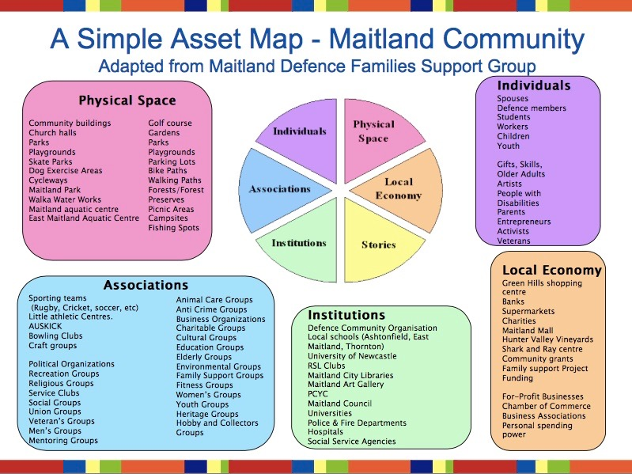
The COLLAB Acronym is a helpful way to frame the process of Community Mapping:

- Communicate & Connect
- Open Opportunities
- Look for Gaps
- Leverage Resources
- Associate with Partners
- Build Relationships

The end result may look like a document you create that contains the relevant resources and information to help you better informed in planning your provision and signposting for help.

Communicate & Connect:

- Build Relationships: Begin by reaching out to key individuals and organisations within the community. These might include local businesses, charities, community leaders, and other schools. Establish a network of contacts that you can rely on for resources and support.

- Research Community Assets: Identify existing resources within the community, such as food banks, counselling services, recreational centres, and religious organisations. This helps in creating a comprehensive list of potential partners and resources.

- Set Objectives: Determine what information you need to gather and how it will help in supporting families.

Open Opportunities:

- Identify Key Areas: Focus on understanding the physical spaces, associations, institutions, individuals, and local economy as shown in the community diagram example above. These are the areas where support and resources can be found or developed. What about the local church?

- Engage Stakeholders: Schedule meetings or informal conversations with community stakeholders. Use these interactions to explore existing services, understand their scope, and identify any unmet needs in the community. Who else is working in this space? What about within the school? Then beyond it? Who else knows information that will help?

- Develop Partnerships: Look for ways to partner with local organisations to create new opportunities for families. This could be in the form of joint events, shared resources, or collaborative programmes. This might look like the following:

- Host Community Events: Partner with local groups to hold events that offer services and support to families.
- Build a Volunteer Network: Create a network of volunteers to assist families with various needs.
- Establish Referral Systems: Set up direct referral pathways with local service providers for quick family support.
- Collaborate on Resource Sharing: Work with local organisations to pool and distribute resources effectively.
- Leverage Local Expertise: Engage local professionals to offer services or workshops for families.

DO
Look for Gaps:
- Analyse Findings: Compare the needs of the families you support with the resources available in the community. Consider how you can join the dots.

- Communicate with Families: Use the information gathered to better understand the needs of the families you work with. Tailor your support strategies to address these specific needs, ensuring that families are aware of the resources available to them.

Leverage Resources:
- Mobilise Community Assets: Once resources are identified, consider how you can connect them into your work. This might include negotiating discounts with local businesses for families, setting up referral systems with local healthcare providers, or collaborating with community centres to provide additional services.

- Promote Resources: Educate families about the available resources and how they can access them. This might involve sharing informational brochures, holding workshops, or setting up regular communication channels. Encourage families to engage with the resources and opportunities available in their community. This could be through organised events, community service opportunities, or family-oriented activities.

REVIEW
Associate with Partners:

- Evaluate Partnerships: Regularly assess the effectiveness of your partnerships and community connections. Are they meeting the needs of the families? Are there opportunities to deepen or expand these relationships?

- Gather Feedback: Collect feedback from families about the resources and support they have received. Use this feedback to assess the impact of your community mapping efforts and to identify areas for improvement.

Build Relationships:

- Strengthen Existing Ties: Continuously work on strengthening your relationships with community partners. Regular communication, mutual support, and shared goals will help sustain these partnerships over time.

- Expand Your Network: As your understanding of the community grows, continue to expand your network. Identify new stakeholders and resources that can further support the families you work with.
- Celebrate Successes: Acknowledge and celebrate the successes of your partnerships and the positive impact on families. Share these stories with the wider community to build momentum and encourage further collaboration.

Signpost:

- Create a Resource Directory: Develop a comprehensive directory of the community resources you’ve mapped. Ensure this directory is accessible to families and other stakeholders.

- Maintain Visibility: Regularly update and distribute the resource directory, ensuring that all families are aware of the support available to them. Use various communication channels, such as school websites, newsletters, and social media.

