2. EFFECTIVELY MEASURING IMPACT
This Best Practice Guide is a primer designed to help you measure impact more effectively.
PLAN
RATIONALE

As you plan your activity:
- What Ethos learning outcomes does this link to?
- How does this link to school priorities?
- What am I going to measure? What impact tool am I going to use?
- How will I use the Golden Triangle?

PREPARATION

- Have I got relevant impact tools ready?
- Have I communicated to relevant staff/students about HOW we will record impact?
- What is the time scheduled in for this impact recording to happen? Make sure it is not an afterthought.
- What photos can I take? Do I have relevant permissions if I want to use them wider than just my internal report?

DID YOU KNOW?
A new GF Survey System is now available for staff that has been designed to support gathering data feedback in a quick and easy manner giving you instant results to share in your reports.
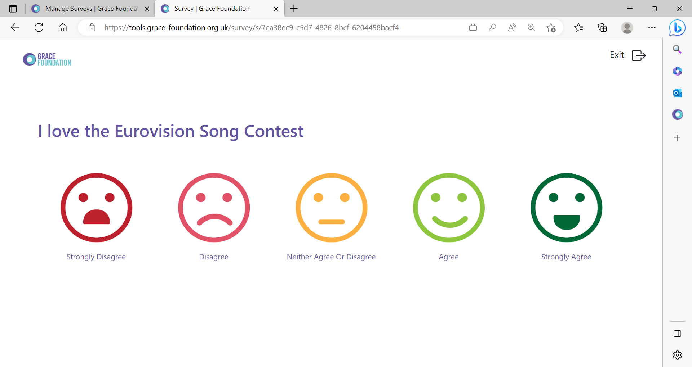
System available via https://tools.grace-foundation.org.uk/
See the additional instructions and guidance document for more detail.

DO
REMEMBER THE GOLDEN TRIANGLE

Stats: These can be collated from multiple sources. Link relevant statistics into your intended outcome.

- Survey feedback stats (Google/Paper/GF Digital System)
- Attitude to Learning / Progress Scores
- Behaviour Points / Positive Points
- Attendance Statistics
- External Surveys and Stats (Regional or National Comparisons)
- Wellbeing measurement i.e.: Rosenburg scale /Warwick scale
- Baseline Assessments of KNOWLEDGE / ATTITUDE / SKILLS

- Last half term, S received 28 negative behaviour points compared to 9 this half term which is a decrease of 68%.
- 96% of students agreed they understand more about how Jesus inspires other through his words and actions.

Student/Staff/ Parent Voice: Listening to what students, staff, and parents say matters.

- Feedback doesn’t ALWAYS have to collected via a paper form!
- Make a note of short statements as a plenary in lessons.
- Use post it notes / Worksheets/ Workbooks/Chalkboards/Creative ways to gather comments.
- Take a snapshot of comments at a break/drop-in or informal event.
- Use a focus group.
- Ask identified students directly and write down their responses.

Do not just focus student feedback on what they learnt,’ i.e.: In a CV Writing Workshop – “I learnt about CV writing.” Say what difference it made and why that matters. “I now feel more confident to get a job as a result of the CV writing workshop and am applying for something this week!”

Avoid vague statements or statements like ‘It was good!’ or ‘I enjoyed it!’

Good examples of Student Voice:

- 'The most important thing I learnt was how to set boundaries and limits, and how this helps build healthier friendships. It's made me feel more proud and less insecure of who I am once I opened up to people who I didn't know very well. As a result, I'm going to treat people much more respectfully and make sure they feel comfortable around me.'
- 'Doing this course has made me realise that some of my friendships are not healthy and as a result I will be careful with who I'm friends with.’

Good examples of Staff Voice:
- "The assembly was really engaging, and the students seemed to enjoy taking part in the quiz. They listened well and heard the key message about how you can have hope at Christmas and give hope to other people".
- ‘Less incidents occurring between H and others. H seems much happier around school.’
- 'I have noticed a positive change in A and the way he interacts with other students. He began as a very quiet, seemingly introverted student but I have noticed that he is beginning to forge some friendships amongst his English group. He is altogether chattier (not in a negative way) and is now more involved in class discussions.'

Good examples of Parent Voice:

- "I am going to hug you. I was so worried about seeing a Family Support Worker, but you are so helpful, and I don't feel like I'm alone anymore. Thank you so much, I wish I had have met you sooner.”

- "I’m so glad and a little worry off my mind as my husband as just lost his job in the week can’t thank you enough."

Stories: Collating simple case studies and anecdotal examples of impact can be a powerful way to demonstrate how you are making a difference.

- Use BEFORE – INTERVENTION – AFTER as a model for recording stories.
- Keep it short, specific, and simple.
- Don’t use abbreviations or jargon.
- Avoid vagueness.
- Always link to school priorities/ outcomes and data wherever possible.
- They don’t have to be “happy every after” but they should show progress.
- Do not include statements like ‘impact to follow.’ Share specific impact every time.
- Make sure it includes no personal identifiable data.
TOP TIP: Imagine you are telling a story that has a beginning, a middle, and an end. We are looking to close the story-loop with our case-studies and share any positive outcomes. Improvements don’t always have to be huge, but we should always show progress.

REVIEW
SHARING IMPACT WITH OTHERS

KEEP YOUR HALF-TERM IMPACT REPORTING UP TO DATE, ACCURATE AND INSPIRATIONAL (IMPACT ORIENTATED). Do it as you go!

Other ways to share your impact:

- Staff Briefing / Staff Bulletin or Newsletter
  - Share a simple success story or piece of evidence with all staff to build positive culture.
- Social Media
  - Retell the success stories across your School social media Page.
- Thank you email
  - Circulate evidence as part of a THANK YOU email with the focus on the staff and students who were involved and helped make it happen. People love being appreciated, and they love hearing examples of impact.
- Notice Boards
  - Use the stats and pictures you have collated to create visual displays or installations.
- Posters / Visuals
  - Make some posters to creatively display quotes and statistics all over the school.

RECORDING IMPACT

POOR EXAMPLE OF IMPACT RECORDING

We did an event with a group of students this half term to help them feel better about themselves. All the Students said they really enjoyed it. 87% of 10 students thought it was great. Student A Said “I really liked this course because I really don’t like being in school.” Staff have said how good it was that this course happened.

Why do you think this is a poor example of impact reporting?
- Too vague – What was the event? Who was it for? Why were they identified?
- Student feedback is not impact related and negative about school.
- Poor use of statistics (87% of 10 could become 9/10)
- No reference to specific staff and impacts

BETTER EXAMPLE OF IMPACT RECORDING

A group of 10 Year 8 girls with self-esteem issues and low attendance participated in a six-session SELF ESTEEM intervention course. Before the course, 9/10 girls reported low confidence, while 9/10 reported a significant increase in confidence afterward. Their average attendance improved from 85% to 95%. Student A shared, “I’ve learned to love myself, recognized why I wasn’t attending lessons, and am now doing better in school.” The Head of Safeguarding noted zero recorded behaviour concerns for all students in the six weeks following the course.

Why do you think this is a better example?
- Is clearer on what it is and who it is for.
- Better student voice that is more specific to personal impact and change.
- Links to school data i.e.: Attendance stats
- Includes a specific comment from someone in authority i.e.: Head of Safeguarding.

How would you improve it?

IMPACT EXERCISE
Based on the below example – what Intervention/s would you do? What impact would you expect to see and how would you record it?
Context | Intervention | Impact
F has been getting angry in lessons due to not being able to handle the pressure of Year 9 and friendship issues. They are unconfident and have low self-esteem. This has led to internal truancy with a group of friends, a drop in attendance, relationship issues, and disruption of lessons for others. | SUGGESTIONS:  You could use a self-esteem topic based 1-1 Intervention.  This would tackle many of the root causes. Group work may not be relevant due to relationship issues but could be used at a later stage as a follow on. | SUGGESTIONS:  Stats: You could use the Shorter Warwick Wellbeing Before/After.  You could include behaviour and attendance data. Note on truancy?  Student Voice: Feedback from student – a clear statement of impact not just ‘ I enjoyed this.’  Stories: A story from the Head of Year / Tutor to demonstrate progress.

